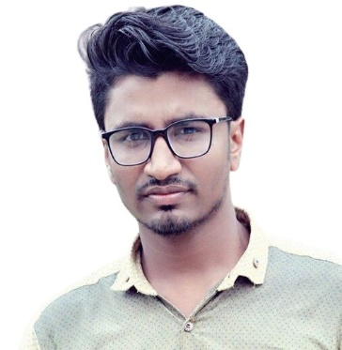 **RESUME**

of

**Md. BELAL HOSSAIN**

**C/O- Md. Samsul Alom**

Vill: Amlagachhi, P.O: Amlagachhi,

P.S: Palashbari, District: Gaibandha.

Cell: +8801792-798678

Email: mdbelal01792@gamil.com

**Career Objective**

To develop my career in national or international Organization where I can utilize my analytical, problem solving and interpersonal communications and presentation skills very effectively for facilitating the development of the organizations to meet the rapid growing demand, global marketing and economic growth.

**Educational Qualification**

**Bachelor of Computer Science and Engineering (B.S.C)**

* **Institution : Northern University Bangladesh.**
* **Subject : Computer Science and Engineering.**
* **Board : Dhaka.**
* **Result : GPA 2.90 (Out of 4.00)**
* **Passing Year : 2022**

**Higher Secondary Certificate (H.S.C)**

* **Institution : Palashbari Govt. College**
* **Group : Science.**
* **Board : Dinajpur.**
* **Result : GPA 3.20 (Out of 5.00)**
* **Passing Year : 2016**

**Secondary School Certificate (S.S.C)**

* **Institution : Amlagachhi B.M High School.**
* **Group : Science.**
* **Board : Dinajpur.**
* **Result : GPA 4.13 (Out of 5.00)**
* **Passing Year : 2012**

**Language Proficiency**

|  |  |  |  |  |
| --- | --- | --- | --- | --- |
| **Language** | **Reading** | **Writing** | **Speaking** | **Listening** |
| Bangla | Excellent | Excellent | Excellent | Excellent |
| English | Excellent | Good | Good | Good |

**TRANNING Skills**

Visual Basic, HTML, CSS, Bootstrap, Tailwind, WordPress, Java, JavaScript, C, C++.

**COMPUTER Skills**

Ms Office, Ms Excel, Ms Power Point, Ms Access, E-mail & Internet Browsing.

Operating System: Windows 7, Windows 10.

**Personal Information**

**Name : Md. Belal Hossain.**

**Father’s name : Md. Samsul Alom**

**Mother’s name : Mst. Bilkish Begum.**

**Permanent Address : Vill: Amlagachhi, P.O: Amlagachhi,**

**P.S : Palashbari, District: Gaibandha.**

**Present Address : Vill: Amlagachhi, P.O: Amlagachhi,**

**P.S : Palashbari, District: Gaibandha.**

**Date of Birth : 23/11/1997.**

**Sex : Male.**

**Nationality : Bangladeshi (by birth)**

**Religion : Islam (Sunni)**

**Marital Status : Unmarried.**

**NID No : 9152520301**

**DECLARTION**

It is to be declared that statement given here is true. I will be responsible for any type of full or partial false information.

References : Muhammed Samsuddoha Alam

# Assistant Professor : Northern University Bangladesh